**

*Nuances of black and white*

20 January – 7 March, 2020

23 Alserkal Avenue, Dubai

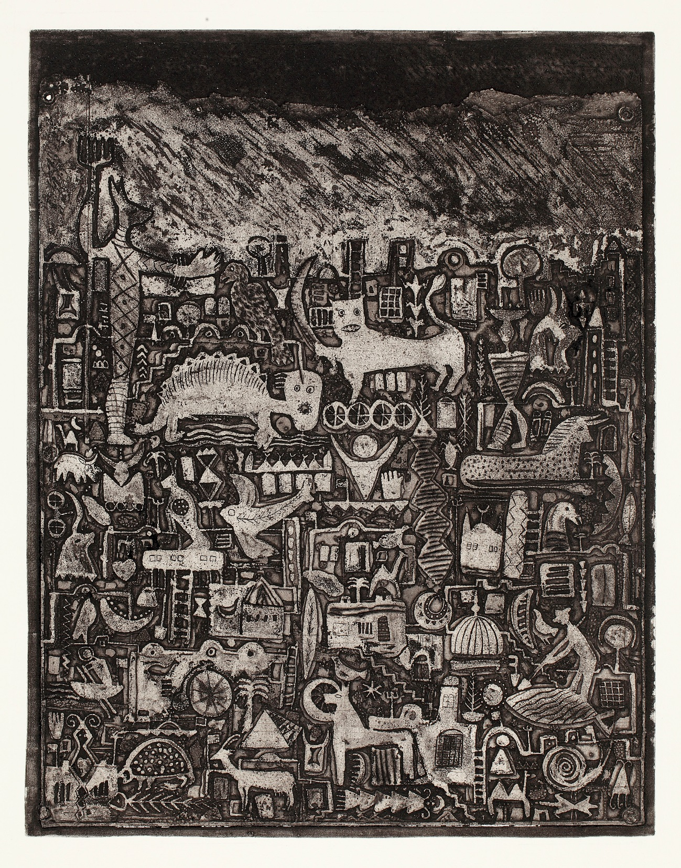

Gouider Triki, *Untitled*, 1978, Etching, 64.7 x 50.4 cm- Engraved in 1978, printed in 2015

Elmarsa Gallery, Dubai is pleased to present *Nuances of black and white,* an exhibition presenting a group of artists using black and white and the nuanced shades in between. On view at the gallery in Alserkal Avenue, Dubai until 7 March 2020, a selection of artworks by Abdelkader Guermaz, Abdulaziz Ashour, Ali Tnani, Aly Ben Salem, Atef Maatallah, Charles Hussein Zenderoudi, Gouider Triki, Halim Karabibene, Khaled Ben Slimane, Mahjoub Ben Bella, Mouna Karray, Nabil Saouabi, Nja Mahdaoui, Omar Bey, Rachid Koraichi and Raeda Ashour. *Nuances of black and white* juxtaposes works that range from realism to abstraction to modern art, comprising a range of media including painting, drawing, engraving, ceramic, mosaic and photography, shining a light on the unique aesthetics of each artist. Though many of these artists are known for their bold utilization of color, their focus on the line, texture, and shadow shapes a more nuanced understanding of their work. In highlighting each artist’s individualized style, this exhibition encourages a conversation across Contemporary and Modern, formal and spiritual movements.

Exhibiting artists

Abdelkader Guermaz, Abdulaziz Ashour, Ali Tnani, Aly Ben Salem, Atef Maatallah, Charles Hussein Zenderoudi, Gouider Triki, Halim Karabibene, Khaled Ben Slimane, Mahjoub Ben Bella, Mouna Karray, Nabil Saouabi, Nja Mahdaoui, Omar Bey, Rachid Koraichi and Raeda Ashour

[**Exhibition**](http://galerielmarsa.com/upcoming.html) **|**[**Artsy**](https://www.artsy.net/show/elmarsa-nuances-of-black-and-white)

Abdelkader Guermaz (Algeria, 1919-1996)

Abdelkader Guermaz grew up in Oran where he studied at the Beaux-Arts from 1938 to 1940. Until 1955, Guermaz worked in the figurative style like the ‘Peintres de la Réalité Poétique’, a French art movement. His early works are typically landscapes and still-lifes. After 1955, he started painting abstract works, and was drawn to the avant-garde artists in Paris where he moved in 1961. He became associated with the School of Paris, befriended French artists such as Bissière, Manessier, Bazaine. Subtlety and minimalism characterize Guermaz’s artistic approach, giving form to his spiritual meditations and inspiring French art critic Pierre Rey to call him the painter of silence and light. In the 1970’s, Guermaz began incorporating modulated neutral fields, punctuated by touches of colour and subtle grid-like patterns, conceived as ‘abstract landscapes’. Attaining critical success in the late 1960s and early 1970s, the artist was largely forgotten upon the 1981 closure of the gallery Entremonde that represented him. His work, featured in international museum collections, has been rediscovered in posthumous shows and texts. Abdelkader Guermaz is considered as one of the founders of modern art in Algeria.

Abdulaziz Ashour (Saudi Arabia, b. in 1962)

Born in Jeddah, Abdulaziz Ashour is a pioneer of the Arab art scene. He is best known for painterly collages featuring newspaper, clods of pigments and technological fragments of CD’s, circuit-boards and wires. He has worked with the Ministry of Energy while exploring his art. He turned a full-time artist in 2009. The artist has also been a consultant (International Plastic Arts) to the Saudi Arabian Ministry of Culture in 2006 and is the founder member of the first active cultural forum for the arts in Jeddah. In 1992, he won the 1st Prize of the Danah Heritage Competition in Jeddah. Abdulaziz Ashour work has been showcased internationally. He frequently participates in group shows outside the Kingdom. In 2008, he has been part of the Edge of Arabia group exhibition at S.O.A.S. He has also taken part in international shows in the Middle East and South America: he represented the Kingdom of Saudi Arabia at the Festival Internacional in Mexico in 1990 and participated to the 8th edition of the 25th February Arts Exhibition in Kuwait and more recently Jeddah Art Week 2014. Ashour compiled and curated the art book *Saudi Artists Today* to capture the richness and variety of the preceding two decades of Saudi art. He currently lives and works in Jeddah.

Ali Tnani (Tunisia, b. 1982)

Ali Tnanigraduated from the Institut Supérieur des Beaux-arts de Tunis in 2007. He lived in Paris, where he was artist in residence at the Cité Internationale des Arts. His conceptual practice combines drawing, multimedia installation and photography to examine the question of erasure and the negative. His work examines social issues in post-revolutionary Tunisia through narratives of traces, memory and history. Tnani’s interest in the trace, either indexical or remnant, is the corollary of a reflection that he is developing on the notion of “counter-spaces”. These “counter-spaces” are both plastic and political: where emerge contradictions which allow to question what would be utopia at the era of ultra-connectivity. Tnani brings up the form - material and immaterial - visually reflected in graphemes of pigments and lead-mine residues which vanish into the surface of his works on paper. He has participated in various solo and group exhibitions internationally, including the Musée du Bardo in Tunis, the Plateforme de création contemporaine in Paris, the 5th Marrakech Biennial, the Musée de Carthage in Tunis and the Musée des Beaux-Arts de Mons (Belgium), the Musée du Montparnasse in Paris and the Biennial of young artists from Europe and the Mediterranean in Skopje, Macedonia. His work is part of private collections in France, USA, and the UK.

Aly Ben Salem (Tunisia, 1910-2001)

Born in Kalaa al-Kebira, Ben Salem was the first Tunisian to attend the Tunis School of Fine Arts. He received the Government Prize of Fine Arts in 1936 and received funding from the Ministry of North African Affairs to go to Paris between 1937 and 1940. He returned to Tunisia for the next decade before migrating to Sweden in 1950, where he would spend the rest of his life. Adapting miniature painting to Tunisian visual culture to create his unique figurative style, he is associated with the École de Tunis, the generation of artists who came of age during Tunisia’s struggle for independence and expressed their patriotism through their art. His work has been shown in Tunisia, Sweden, the United States, Norway and Germany and he received multiple national awards in Sweden, France and Tunisia including Officer of the Swedish Royal Order in 1973, the Mérite National des Lettres et Arts de France in 1976, and Officer of the Tunisian Republic in 1980.

Atef Maatallah (Tunisia, b. 1981)

Born in 1981 in Al Fahs, Tunisia, Atef Maatallah lives and works in Tunis. Maatallah graduated from the Institut Supérieur des Beaux-Arts of Tunis, and pursued his training at the Cite des arts de Paris. His work revisits the codes of narrative figuration depicting ordinary people and objects he encounters in daily life, evoking precariousness of existence. Maatallah's paintings and drawings give a cultural commentary through part of an intimate story or one suggestive aspect of everyday life inside Tunisia’s society relating to historical narratives. He had solo exhibitions at Elmarsa Gallery in 2013, 2014, 2015, 2017 and 2019 in Tunis and Dubai. His works have been presented in exhibitions including L’Institut des Cultures de l’Islam de la Ville de Paris in 2016, Me.Na Pavilion in Singapore in 2014 curated by Catherine David from the Centre Pompidou, and have been widely shown at art fairs in Dubai, Abu Dhabi, Miami, Marrakech, London, Paris, New York. He was twice the recipient of the Prize of Paris Contemporary Drawing in 2015 and 2016. His works have been acquired by various private and public collections in North Africa, Europe and the Middle East, including Barjeel Art Foundation, Kamel Lazaar Foundation and the Ministry of Culture in Tunisia.

Charles Hossein Zenderoudi (Iran, b. 1937)

Born in 1937 in Iran, Hossein Zenderoudi studied at the College of Fine Arts and the College of Decorative Arts in Tehran. He’s known as a pioneer of Iranian modern art and now lives and works in Paris. In the late 1950s, Zenderoudi founded the Saqqakhana movement. Meanwhile, he was encouraged to move to Paris, when the French government granted him a scholarship at the Ecole Nationale des Beaux-arts in Paris in 1960. Drawing inspiration from Muslim art, Zenderoudi develops elegant friezes of graphic rhythms, assiduously calligraphed and reminiscent of Qur’anic writing, perhaps with a subtle allusion to the combinations of symbols in Gothic art. Zenderoudi’s open-minded approach leads him to constantly expand as a painter, a sculptor, a photographer, a book illustrator. His career studded with landmark achievements, he has also received many public and private architectural commissions. In 1973, Zenderoudi won the UNESCO award for ‘The Most Beautiful Book of the Year’. He exhibited extensively at the Paris, São Paulo and Venice Biennales and won one of the main royal prizes at the Tehran Bienniale. Zenderoudi participated in various worldwide exhibitions, such as at Leila Heller Gallery in New York, Stadler Gallery in Paris, Carini Gallery in Milan, Leighton House Museum in London, and Tehran Museum of Contemporary Art among many others. His work can be found in many private and public collections including the British Museum in London, the Centre Pompidou in Paris, the National Center of Contemporary Art (CNAC) in Paris, the Museum of Modern Art (MoMA) in New York, the Voor Volkenkunde Museum in Rotterdam, the Museum of Contemporary Art in Tehran, the Arab Museum of Modern Art (Mathaf) in Doha, the Statens Museum in Copenhagen, the Modern Art Museum in Amman, among many others.

Gouider Triki (Tunisia, b. 1949)

Born in 1949 in Nabeul, Tunisia, Triki studied at L’Ecole des Beaux-Arts in Tunis before pursuing a residency at the Cité Internationale des arts de Paris. He started his career living and working between Tunis and Paris in the mid1970s and 1980s. Triki retired in the natural world of his native town of Lezdine in north-eastern Tunisia, grounded in the rural community. Triki’s paintings and engravings are filled with mystical symbols and patterns inspired by his Berber heritage. His abstract surreal compositions are filled with flora and animal forms, reflecting his experience of working on the land, but also with popular figures wearing archaic outfits. Although connections can be made with the imaginative world of the Swiss artist Paul Klee, Triki draws principally on his own country's oral tradition of folk stories. His works have been widely exhibited in Tunisia and abroad since the mid-1960s, including at the Musee d’Art Moderne de Paris - Centre Pompidou and the Institut du Monde Arabe in Paris. He was awarded the Presidential Prize of Tunisia in Painting. His works are part of private and public collections mainly in North Africa, Europe and the Middle East.

Halim Karabibene (Tunisia, b. 1962)

Born in Bizerte (Tunisia), Halim Karabibene came to recognition in the 1990s due to his unusually sarcastic yet masterfully executed collages and oneiric paintings. Throughout his career, Karabibene has formally explored an alternative universe, one that is hybrid and playfully "staged" with a whole range of mythical neo pop characters. Since 2007, Karabibene has been pursuing a multidisciplinary performance in which he has been encouraging public authorities to inaugurate Tunisia's first National Museum of Modern and contemporary Art (MNAMC). With a pressure cooker as symbol and form of the future Museum, Karabibene uses social networks, events and exhibitions to effectively launch this pseudo fictional museum until it sees the light. Between 1982 and 1993, Karabibene has studied architecture and attended the École Nationale Supérieure des Beaux-Arts in Paris. From 1999 to 2001, he lived at the Cité Internationale des Arts of Paris. Represented by Elmarsa Gallery, Karabibene's work has been widely exhibited in private institutions and museums around the world, including at the ifa gallery in Berlin and Stuttgart, the Barjeel Foundation in Sharjah, the Museo Vittoriano in Rome, the Institut du Monde Arabe in Paris, the Musée d’Art Moderne in Algiers, the Museo Pontevedra in Spain, etc. Karabibene lives and works between Tunis, Bizerte and Berlin.

Khaled Ben Slimane (Tunisia, b. 1951)

Born in Nabeul (Tunisia), Ben Slimane studied at the Uscuela Massana of Barcelona and Technological Institute of Art in Tunis. He currently lives and works in Tunis. His multi-disciplinary practice includes paintings on paper, canvas and wood as well as ceramic and bronze sculptures. A synthesis of East and West, his work invokes Sufism through graphic repetition in a distinctive style. Since his first exhibition in Tunisia in 1982, he has been exhibiting worldwide, including Galerie Le Passage in Berlin (1988), the Leighton House Museum in London (1995), the Museu de Ceramica of Barcelona (2001), and Elmarsa Gallery in Tunis (2016) and in Dubai (2018). In 2004 and 2005, his exhibition “From Earth to the Sky - Ceramics and Paintings”, curated by Badischen Landsmuseums travelled in five different museums in German cities including in Karlsruhe, Stuttgart and Düsseldorf. His works have been widely exhibited from Tunis, Baghdad, Rabat, London, Paris and Rome to New York, including MNAM-Centre Pompidou and Institut du Monde Arabe in Paris, Musée d’Ethnographie de Corse, the British Museum in London and Palais des Gouverneurs Génois in Bastia. His work can be found in numerous private and public collections, such as the British Museum, the Smithsonian Institution in Washington D.C., the Idemitsu Museum of Arts in Tokyo, the Benaki Museum in Athens, the Jordan National Gallery of Fine Arts in Amman, the Badisches landesmuseum in Karlsruhe and the Museu de Ceramica de Barcelona.

Mahjoub Ben Bella (Algeria, b. 1946)

Born in Algeria in 1946, Mahjoub Ben Bella studied at the Fine Arts School of Oran before joining the Academy of Arts in Tourcoing in Northern France, where he currently lives and works. He received master’s degrees at both the National School of Applied Arts and the National Fine Arts Academy of Paris. His unique visual language is composed of motifs, shapes and colors that emerge out of his treatment of traditional Arabic calligraphy in the European painting tradition. In addition to major international commissions ranging from a 1982 mural in Riyadh airport and a 12 km painted course for the 1986 Paris-Roubaix international bicycle race to a portrait of Nelson Mandela at the Wembley stadium in the UK in 1988 and ceramic tiles in the metro station in Tourcoing in 2000, Ben Bella’s work has been widely exhibited around the world and acquired by prestigious collections and museums.

Mouna KARRAY (Tunisia, b. 1970)

Born in Sfax (Tunisia), Mouna Karray studied art and culture in Tunis before moving to Tokyo to complete an MA specialising in photography at the Tokyo Institute of Polytechnics and Arts in 2002. Currently living and working between Paris and Sfax, Karray merges socio-political themes with personal experience to explore constructions of identity and memory. She had solo exhibitions including at Elmarsa Gallery where she presented her series Murmurer in 2011, at the opening exhibition of Zeitz MOCCA in Cape Town in 2017 and at Tyburn Gallery in London in 2016. She was received in in several art residencies in Tunisia, France, Italy and Québec. Mouna Karray has been exhibiting extensively in museums and biennales such as Le Musée de la Ville de Tunis in 2006, the Museum of Contemporary and Modern Art in Algiers (MAMA) in 2008, the Quai Branly Museum in Paris in 2009, the Palace of Fine Arts in Brussels, the Ecole Nationale Superieure des Beaux-Arts de Marseille in 2011, the MAXXI, in Rome in 2013, the SCAD Museum of Art in Savannah, USA in 2014, the Simithsonian National Museum of African Art in Washington DC in 2015, the 12th Biennale of Contemporary African Art in Dakar in 2016,  the MACCAL in Marrakech in 2018, to name but a few. She has been exhibiting in numerous international shows in Europe, Africa and the Middle East including the 30th Pontevedra Biennial in Spain the 9th African Encounters of Photography of Bamako in Mali, the 2nd Lumumbashi Biennial in Congo and curator Simon Njami’s group show at the MMK Museum für Moderne Kunst in Frankfurt. Her work can be found in many private and public collections including Zeit MOCCA, Cape Town, South Africa; Nadour Collection; Sindika Dokolo Collection; Ministry of Tunisian Culture.

Nabil Saouabi (Tunisia, b. 1972)

Nabil Saouabi explores various mediums such as drawing, painting and engraving, which plays a major role in his work. He obtained a Masters in Visual Arts in 2002 and a PhD in Science and Technical Arts at the Institute of Fine Arts in Tunis in 2013, where he currently teaches drawing. Saouabi creates an imaginary world in which a central character emerges constantly. It is a thick, bald and prehistoric man assuming the role of the artist himself, and on occasion, it is just his tools which appear in his works - brushes and tubes of paint - evoking his consistent presence and underlying commentary. It is a world which constantly oscillates between the external and internal (his studio). The representation of the political imagery has imposed itself in the process of the “mise en abîme” and the “mise en scène” of the artist’s studio. Inspired by the narrative figuration, his work astonishes through satirical staging of various situations and political characters. His pictorial approach shows a certain urgency of expression associated with his sharp critique of Tunisian society post-revolution. He had a solo exhibition at Elmarsa Gallery in Tunis in 2014 and participated in numerous exhibitions both in Tunisia and abroad, including biennales such as Dak'art, Alexandria Egypt, Beijing, and the 5th International Biennial of Engraving of Île de France. His works are in private collections in Tunisia, France, Germany as well public collections such as the Ministry of Culture in Tunisia.

Nja Mahdaoui (Tunisia, b. 1937)

Born in 1937 in Tunisia, Nja Mahdaoui graduated from the Academia Santa Andrea in Rome and the École du Louvre in Paris , where he also pursued further training at the Cité Internationale des Arts. Famous for his meticulous work in ink on parchment, he is considered ‘an explorer of signs’ and a ‘choreographer of letters’. Nja creates rhythmic abstract compositions inspired by Arabic calligraphy. His works have been widely shown around the world in GCC, Asia, America, Africa and Europe. He has illustrated legendary or sacred texts, including tales from the collection of “One Thousand and One Nights” in an outstanding publication in French. In 2018, Elmarsa Gallery in Tunis presented a retrospective exhibition of his works from 1966 to 2018. His work has been presented in international art fairs in Basel, Paris, Abu Dhabi, Dubai, Marrakech and Miami. He has been Jury member and Honor guest of many international events and biennales such as the UNESCO Prize for the Promotion of the Arts. He has received a number of distinctions and international awards. His works can be found in numerous international private and public collections including the British Museum and the Smithsonian Museum in Washington DC, the Mathaf in Doha, the Institut du Monde Arabe (IMA) in Paris, the National Gallery of Kuala Lumpur.

Omar Bey (Tunisia, b. 1972)

Omar Bey was born 1973, to a Tunisian father and a British mother. Since 1996, he began his career as an artist, with an illustrated book titled "Hannibal, the challenge of Carthage". Following his graduation from L’Institut Supérieur des Beaux-art in Tunis in 1998, Bey held his first solo exhibition "Red" at El Teatro Gallery in Tunis. Driven by his success, Bey then settled in Paris where he lived for many years, exhibiting his works there before and after his return to Tunis. He completed a residency at the Cité Internationale des Arts during 2011-2012. Bey’s works include painting, collage and mixed media assemblage of found objects. He has developed an innovative command of materials that enable him to evoke surprise, humor, and contemplation in viewers. Bey’s themes revolve around the paradoxical excess of human existence. Each work explores an absurdity which is echoed in its construction with materials that seem to contradict one another. His work is akin to “art brut” and is characterized by his juxtaposition of solid heavy objects, with light airy materials. Bey’s latest works reflect a more direct and personal engagement with the tensions of his own experiences in Tunisia, but that are also transmutable to broader contexts. His works are presented in various international art fairs in Paris, London, Dubai, Abu Dhabi, New York.

Rachid Koraichi (Algeria, b. 1947)

Born in 1947 in Ain Beida, Algeria, Rachid Koraichi lives and works between Tunisia and France. He studied at the Institute of Fine Arts and the Superior National School of the Arts in Algeria, before moving to France to continue his further studies at the National School of Decorative Arts and the School of Urban Studies in Paris. Koraichi’s sculptural explorations extend across an impressive range of different media, with his installations including ceramics, textiles, various metals and painted work on silk, paper or canvas. Beginning with the intricate beauties of the Arabic calligraphic scripts his work is composed of symbols, glyphs and ciphers drawn from a wide variety of other languages and cultures. Rachid Koraichi was included in the international touring exhibition Short Century, and in the 47th and 49th Venice Biennale, and in Word into Art at the British Museum, 2006. His works have been widely exhibited around the world, and can be found in many private and public collections including the British Museum, London; the National Museum for African Art, Washington; the Museum of Islamic Arts, Doha and many more. In 2010, he contributed works to the Centro Cultural Banco do Brazil’s exhibition Isla, (Islam) and The Future of Tradition – The Tradition of Future, at the Haus de Kunst, Germany.

Raeda Ashour (Saudi Arabia, b.1958)

Raeda Ashour is a member of the women's Saudiaat Art Group in Jeddah.  After living and working in publishing in Cairo where she completed her BA in Middle East Studies from the American University, Raeda Ashour returned to Saudi Arabia in 1993. She joined workshops 'Geometry and pattern, adornment in islamic art' in 2006 and 2007 at The Prince's School of Traditional Arts in London and received a MA in art education at Rushmore University in 2007. Since 1992, she had solo exhibitions in Cairo, in Jeddah and at Darat al Founoun in Kuwait. Her work was presented in various collective exhibitions in Saudi Arabia, Lebanon, Iran, Tunisia, Spain, Russia, UAE. She was awarded several Saudi prizes for her achievements in the arts. Her work is part of major public collections in Saudi Arabia such as the Ministry of Foreign Affairs, the Ministry of Education, Al Mansouria Foundation, and the Collection of the King Abdul-Aziz Public Library, among many others.

About the gallery

Elmarsa was founded in 1994 in Tunis and expanded to Dubai in 2015. Specialized in both modern and contemporary North African art, it represents recognized 20th century artists as well as mid-career artists. Elmarsa participates in several international art fairs in Dubai, Abu Dhabi, Paris, London, Marrakech, Miami and New York.

2 place du Saf Saf

2070 La Marsa, Tunisia

T: 216-71-740572

23, Alserkal Avenue

Al Quoz 1, Dubai, UAE

T: 971-4-3415806

[info@galerielmarsa.com](mailto:info@galerielmarsa.com)

[www.galerielmarsa.com](http://www.galerielmarsa.com/)

[cid:image003.png@01D4D344.62DACB90](https://www.instagram.com/elmarsagallery/)

[cid:image004.png@01D4D344.62DACB90](https://www.facebook.com/Elmarsagallery/)

[cid:image005.png@01D4D344.62DACB90](https://goo.gl/maps/a9fJu2DjmuS2)

|  |  |  |  |  |  |  |
| --- | --- | --- | --- | --- | --- | --- |
|  | | | | | | |
|  |  |  |  |  |  |  |